Tasks To Be Performed:

1. Add 2 nodes to Jenkins master

2. Create 2 jobs with the following jobs:

a. Push to test

b. Push to prod

3. Once a push is made to test branch, copy Git files to test server

4. Once a push is made to master branch, copy Git files to prod server.

Procedure:

Let us take the example of the previous example where we had the Develop branch we will call it as the Test branch. Inside it we will have three files called as the Testfile, test2file and masterfile.

We will create a new node called slave-prod

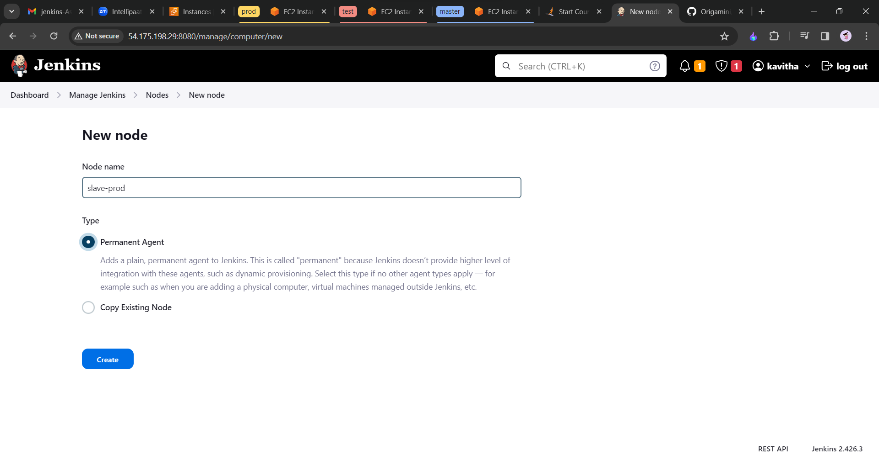

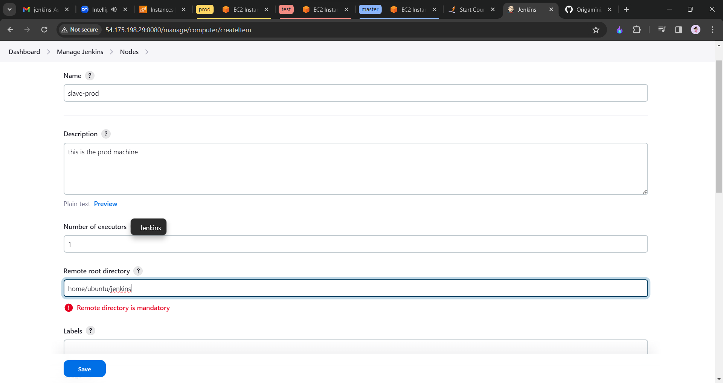

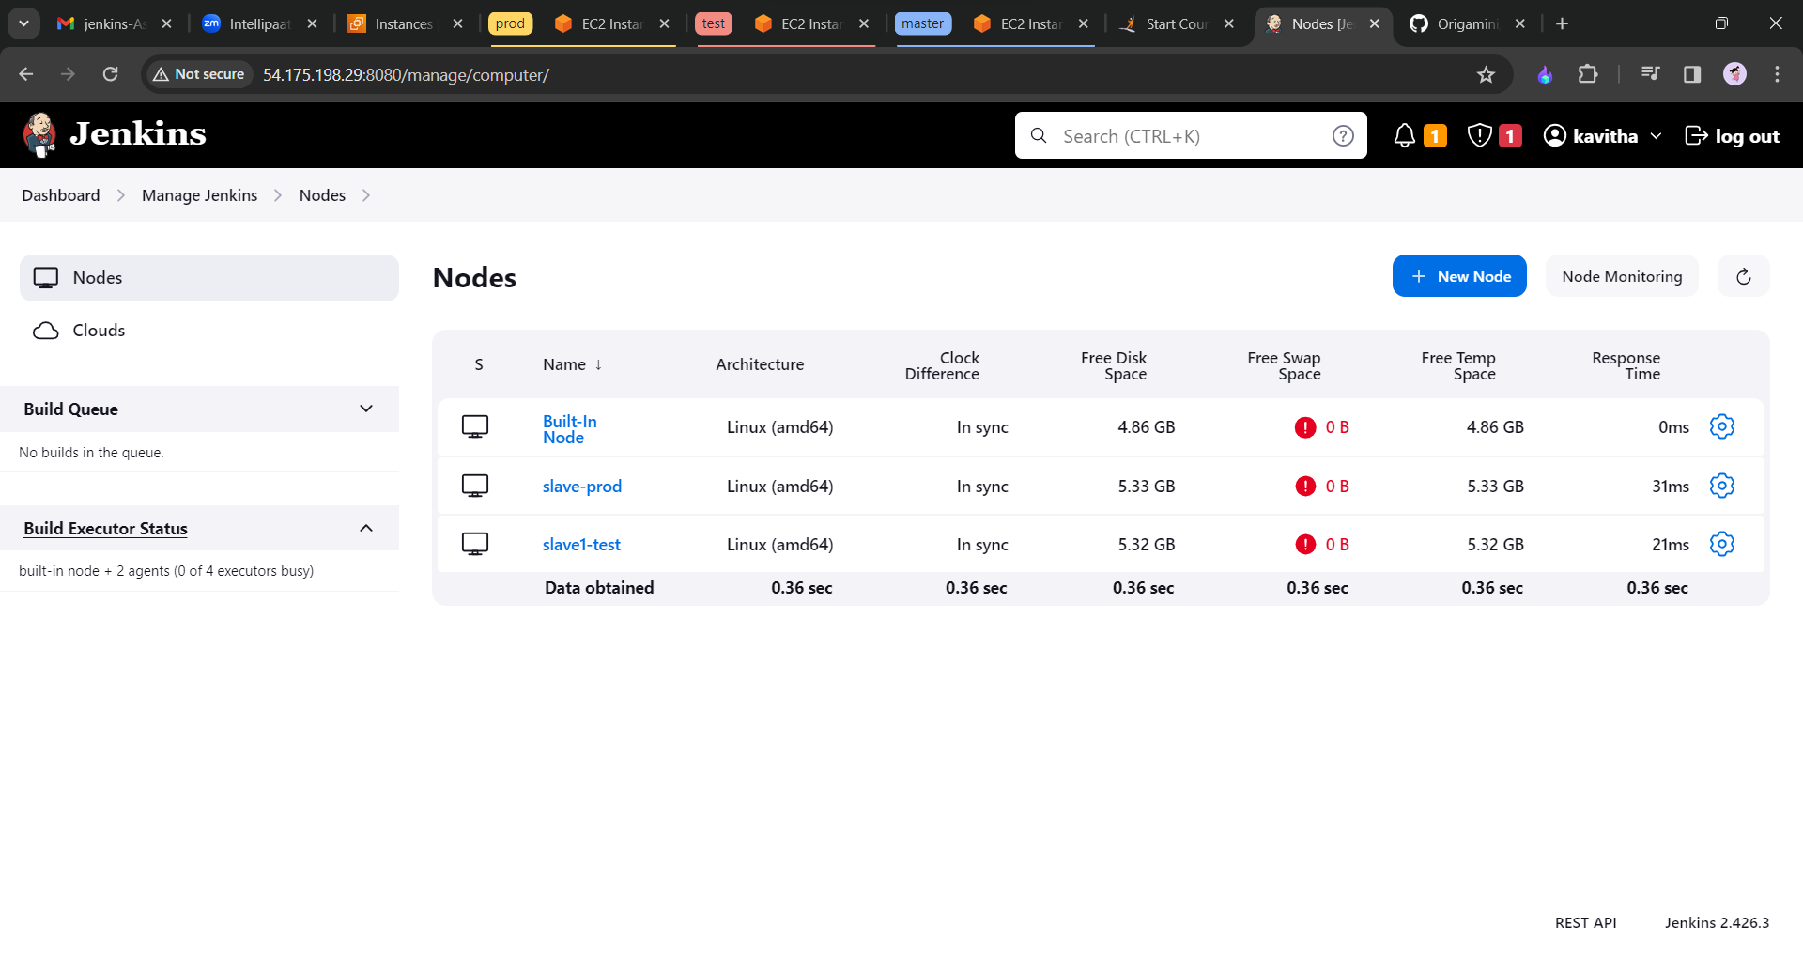

Now we need to createa the new job.

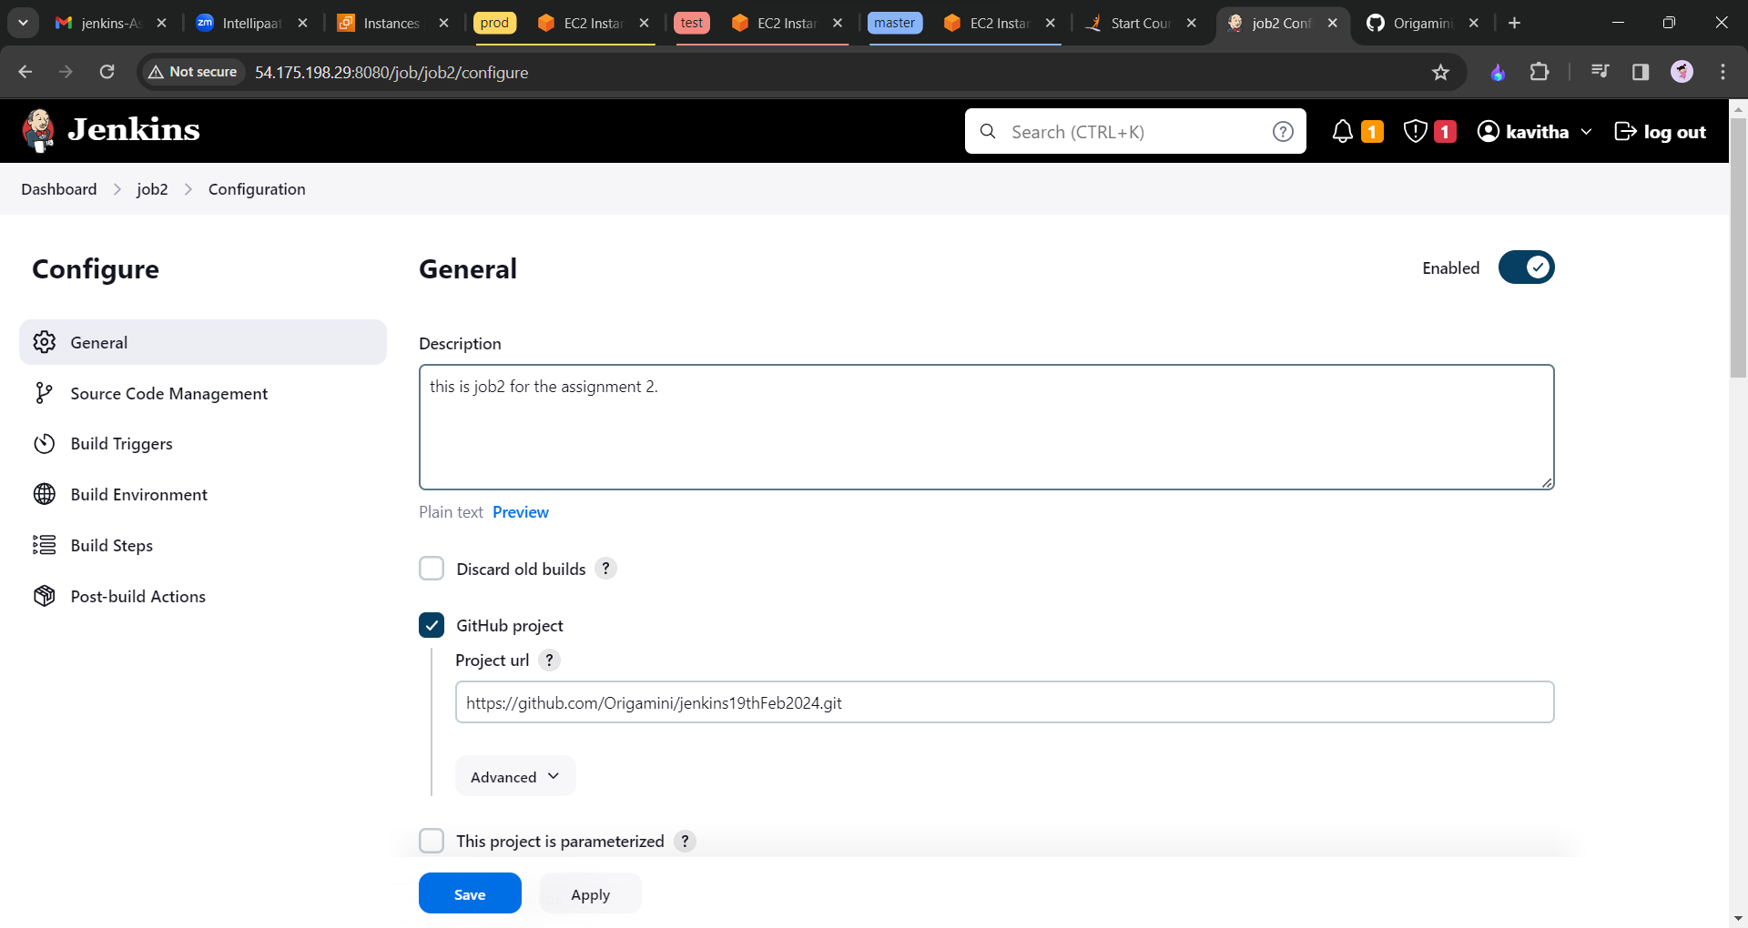

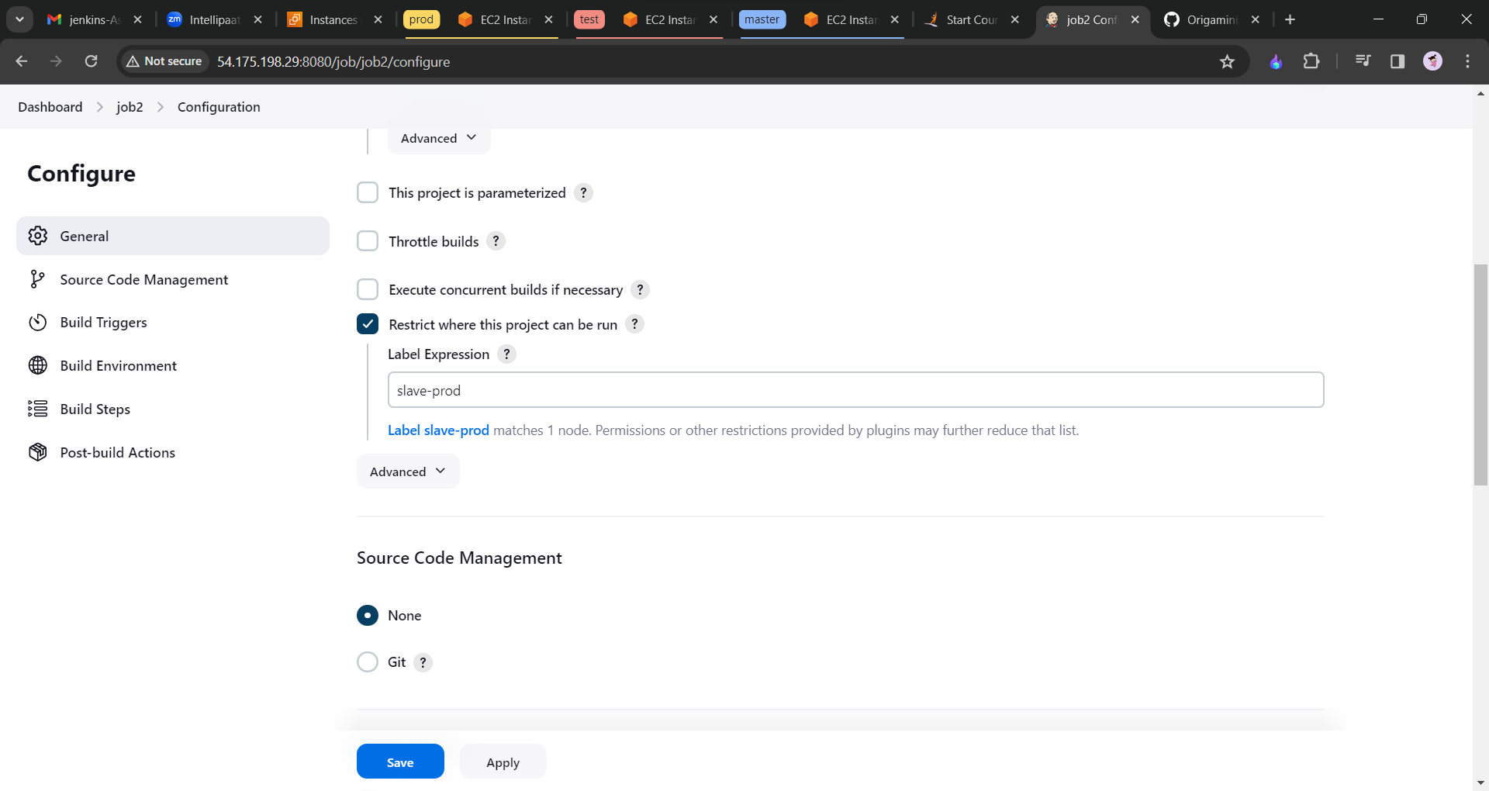

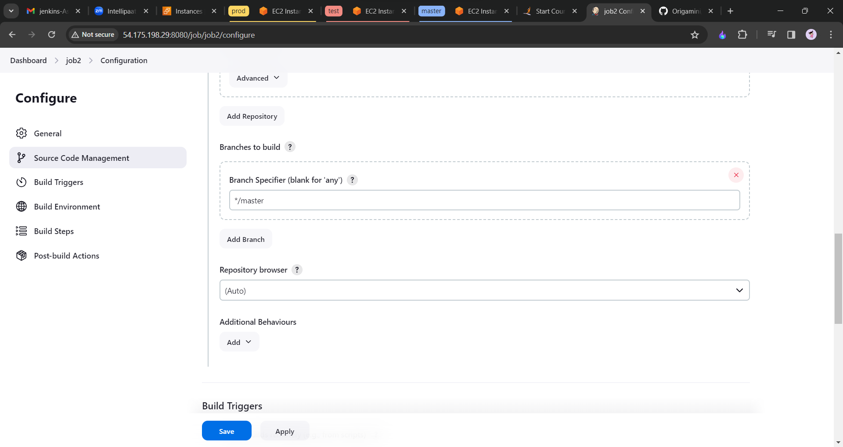

Click on save and apply. Now if we push any thing on the master branch if will directly go to the slave1-prod machine.

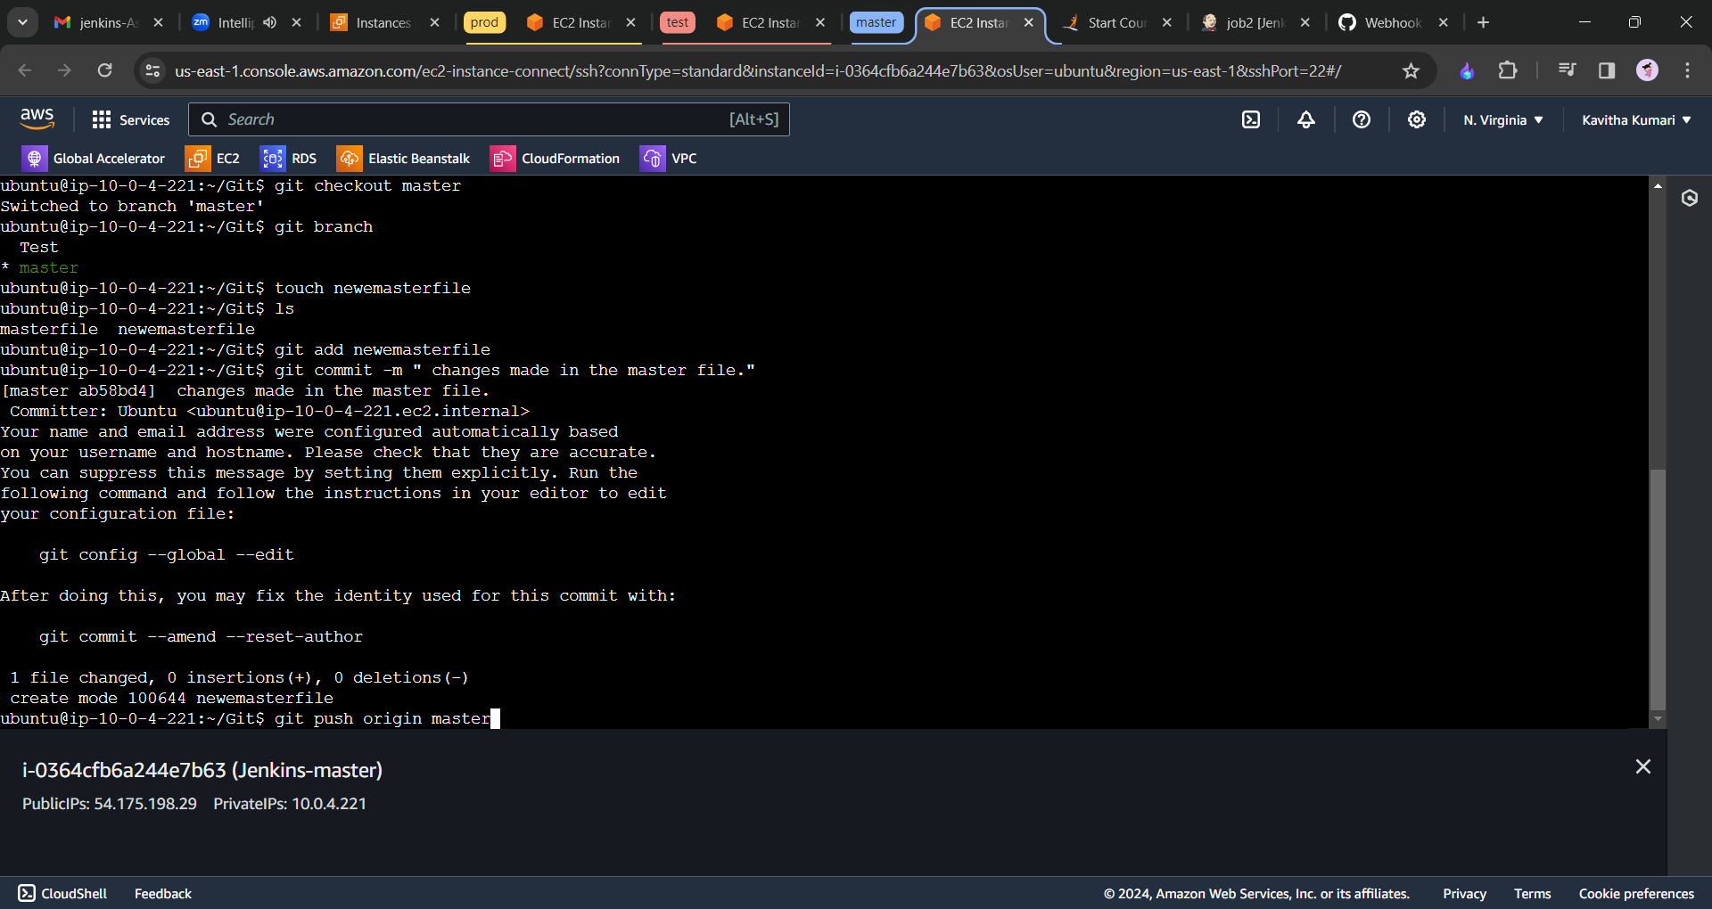

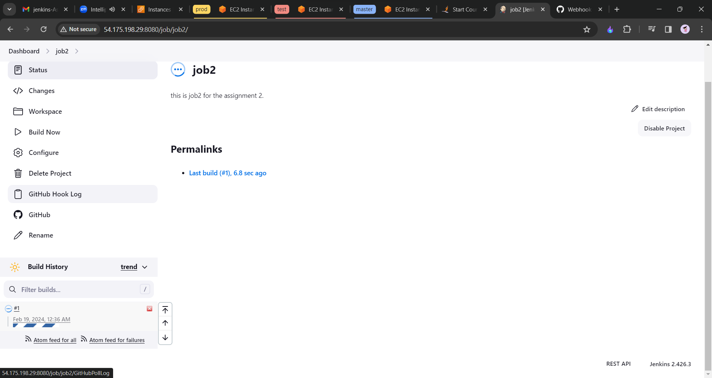

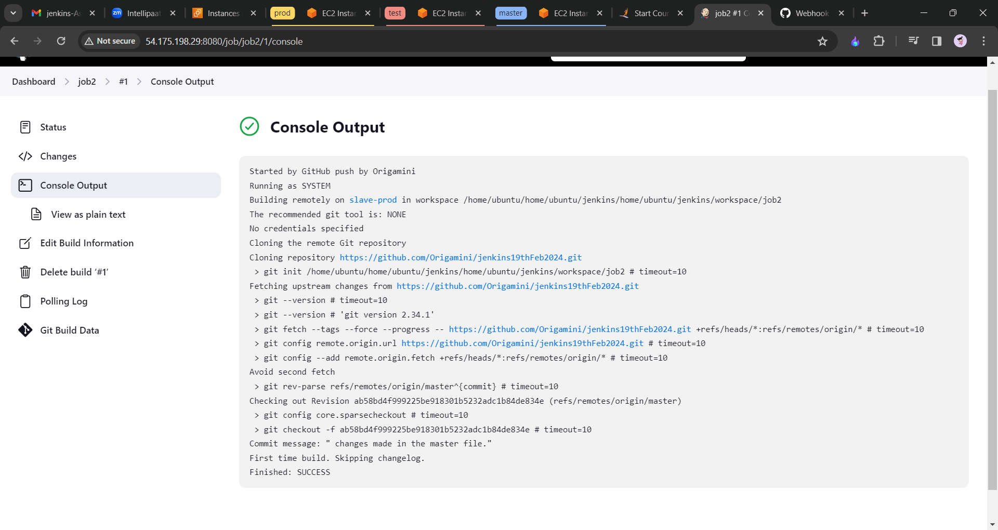

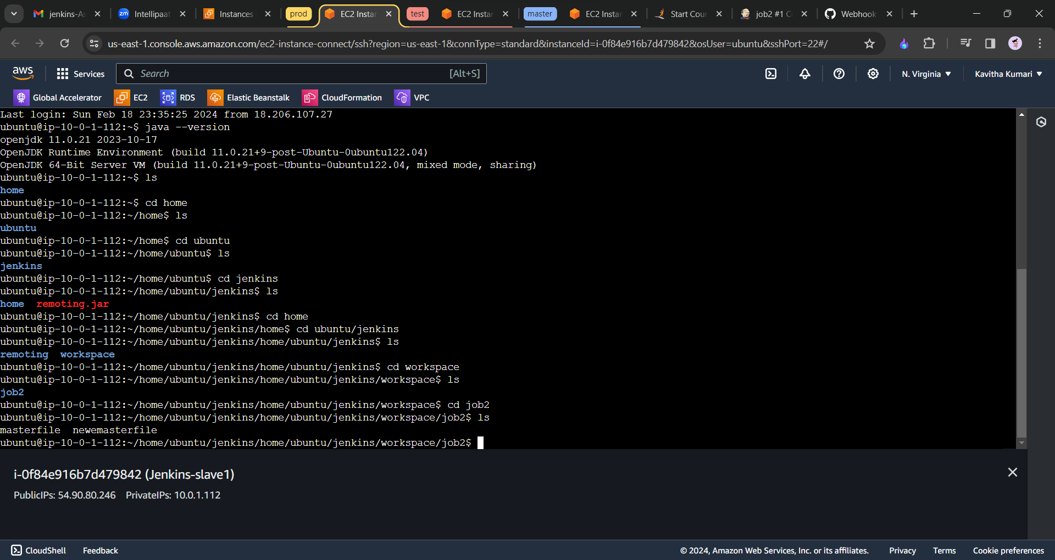

---end----